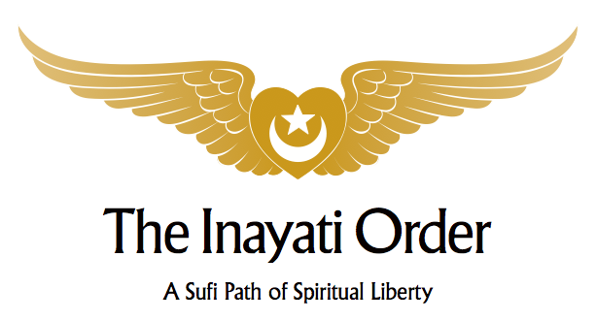

**Wisdom of the Prophets – Part III**

**Sufism & Zoroastrianism w/ Pir Zia Inayat-Khan,**

**Dr. Jehan Bagli and Dr. Sousan Abadian**

**November 10-13, 2016, New Lebanon, New York**

**Agenda**

**Thursday, November 10th**

2:00 – 6:00 pm Registration   
6:00 – 6:45 pm Dinner  
6:45 – 8:30 pm Sufism & Zoroastrianism: A Historical Introduction (*Pir Zia Inayat-Khan)*

**Friday, November 11th**

8:00 – 9:00 am Breakfast  
9:00 – 10:30 am Teachings of the Prophet Zarathustra (*Dr. Jehan Bagli)*

10:30 – 11:00 am Tea Break

11:00 – 12:30 pm The Ahunvar (*Pir Zia Inayat-Khan*)  
12:30 – 1:30 pm Lunch  
1:30 – 2:30 pm Free Time  
2:30 – 3:45 pm Religious Narrative & Zoroastrianism (*Dr.* *Sousan Abadian*)  
3:45 – 4:15 pm Tea Break  
4:15 – 5:30 pm Angels & Adversaries (*Pir Zia Inayat-Khan)*  
6:00 – 7:00 pm Dinner  
7:30 – 9:00 pm Student Presentations (Public)

**Saturday, November 12th**

8:00 – 9:00 am Breakfast  
9:00 – 10:30 am The Living Earth (*Pir Zia Inayat-Khan*)  
10:30 – 11:00 am Tea Break  
11:00 – 12:30 pm Collective Trauma and Zoroastrianism (*Dr. Sousan Abadian*)12:30 – 1:30 pm Lunch  
1:30 – 2:30 pm Free Time  
2:30 – 3:45 pm Fire (*Pir Zia Inayat-Khan*)  
3:45 – 4:15 pm Tea Break  
4:15 – 5:30 pm Ritual Tradition in Zoroastrianism (*Dr. Jehan Bagli*)  
6:00 – 7:00 pm Dinner  
7:00 – 8:30 pm Tea, Dessert & Conversation in the Abode Library

**Sunday, November 13th**

8:00 – 9:00 am Breakfast  
9:00 – 10:30 am The Future of Zoroastrianism (*Pir Zia, Dr. Jehan Bagli, Dr. Sousan Abadian)*  
10:30 – 11:00 am Tea Break  
11:00 – 12:30 pm Universal Worship   
12:30 – 1:30 pm Brunch